New Absence Entry
There are now three options available on the Time and Absence screen
Before: “Existing Time Cards” and “Absence Records”
After: An additional tile called “Absence Balance”
Is the Process changing?
Existing Time Cards: No change
Absence Records: No change
Absence Balance: You can view the Accrual balances and enter an absence here.
To enter an absence from this tile, click on the Actions Button on the top right corner as shown in the screen shot below:
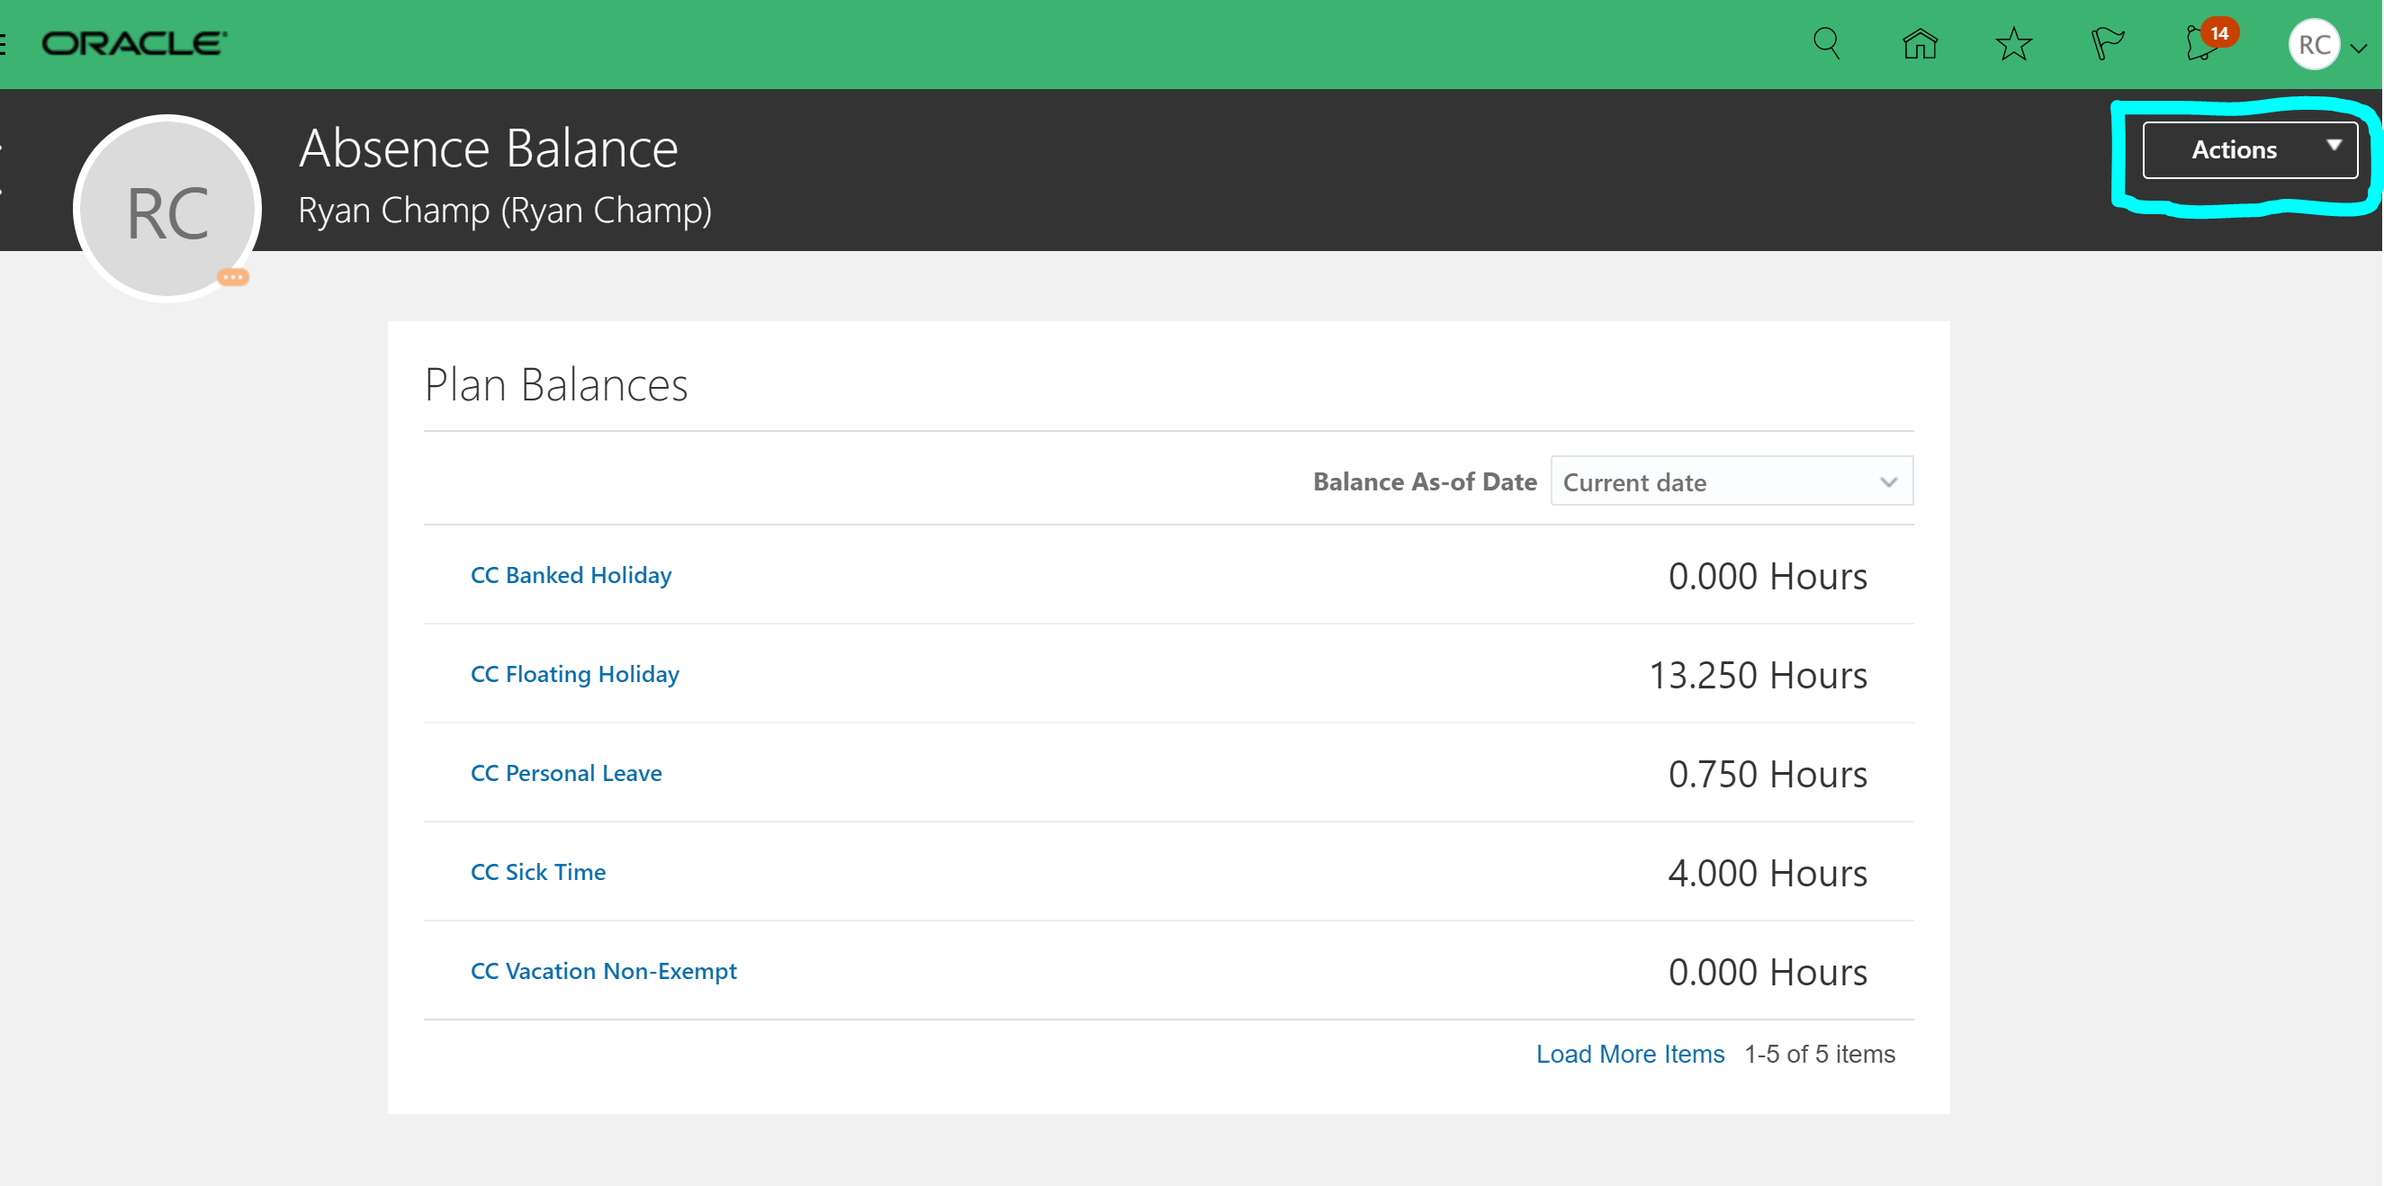
Click Add Absence
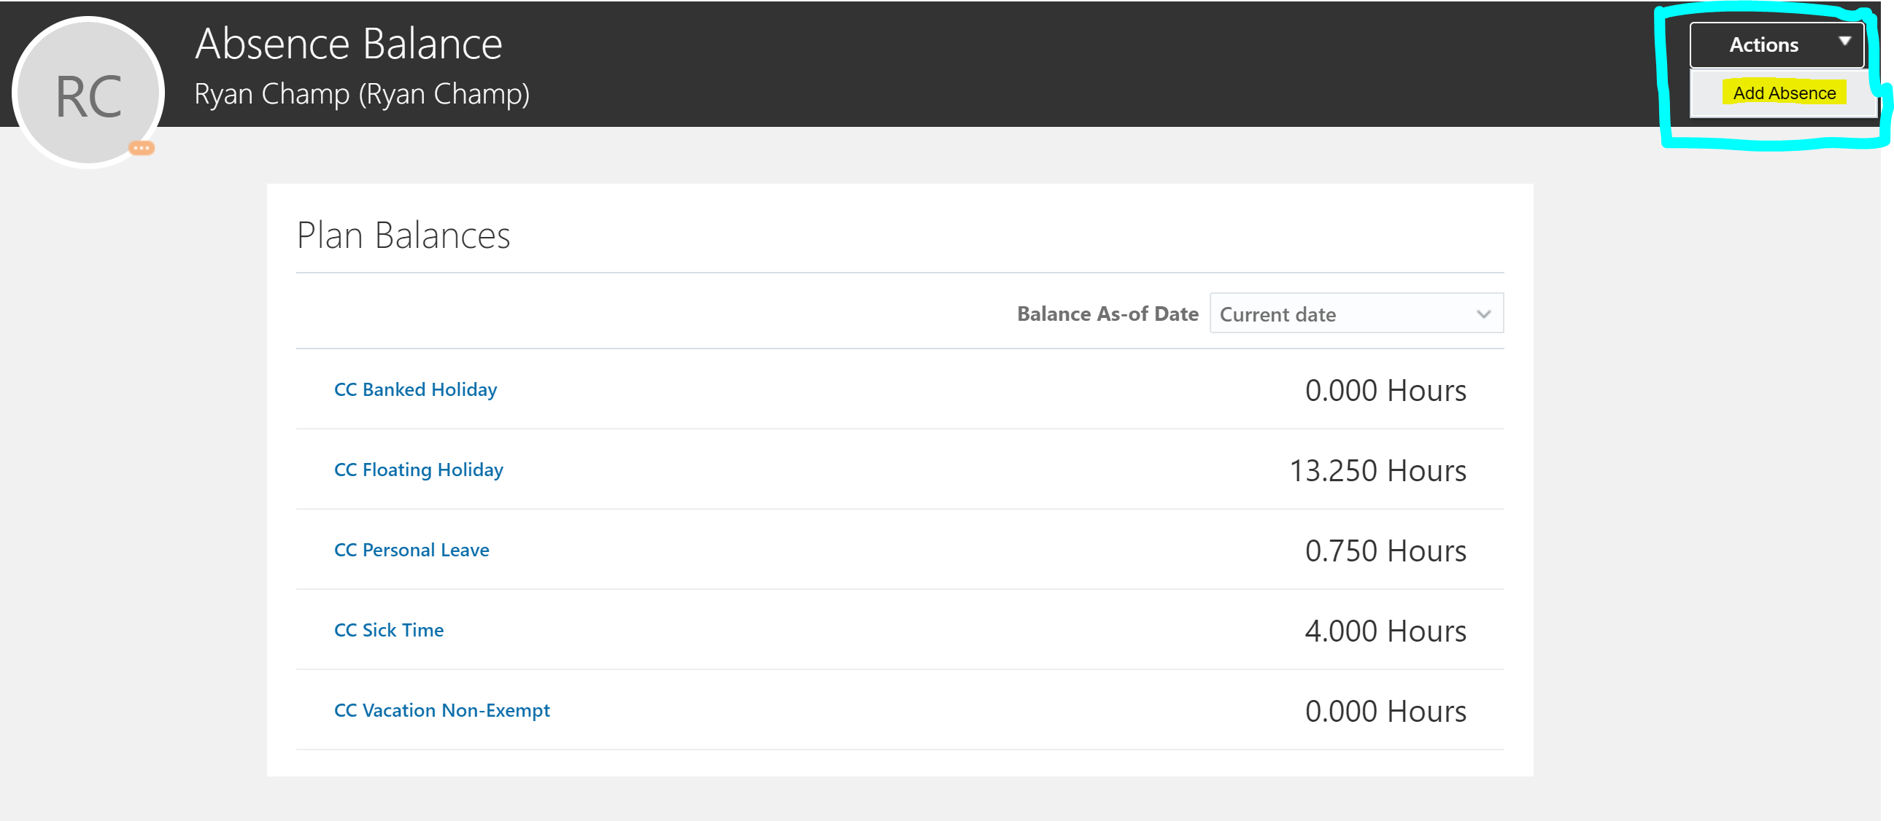

Select an Absence Type under the drop down
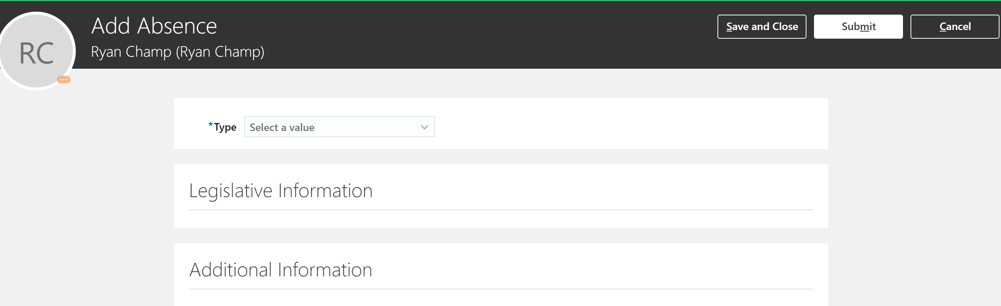
Enter your information
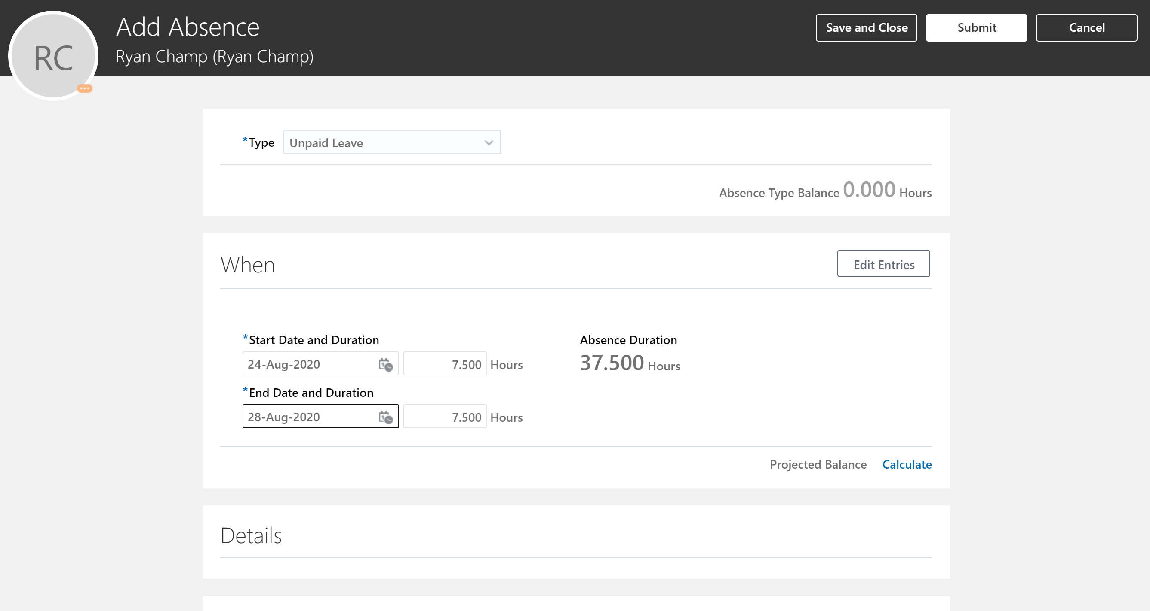

Click on Edit Entries to enter Absence for multiple Assignments.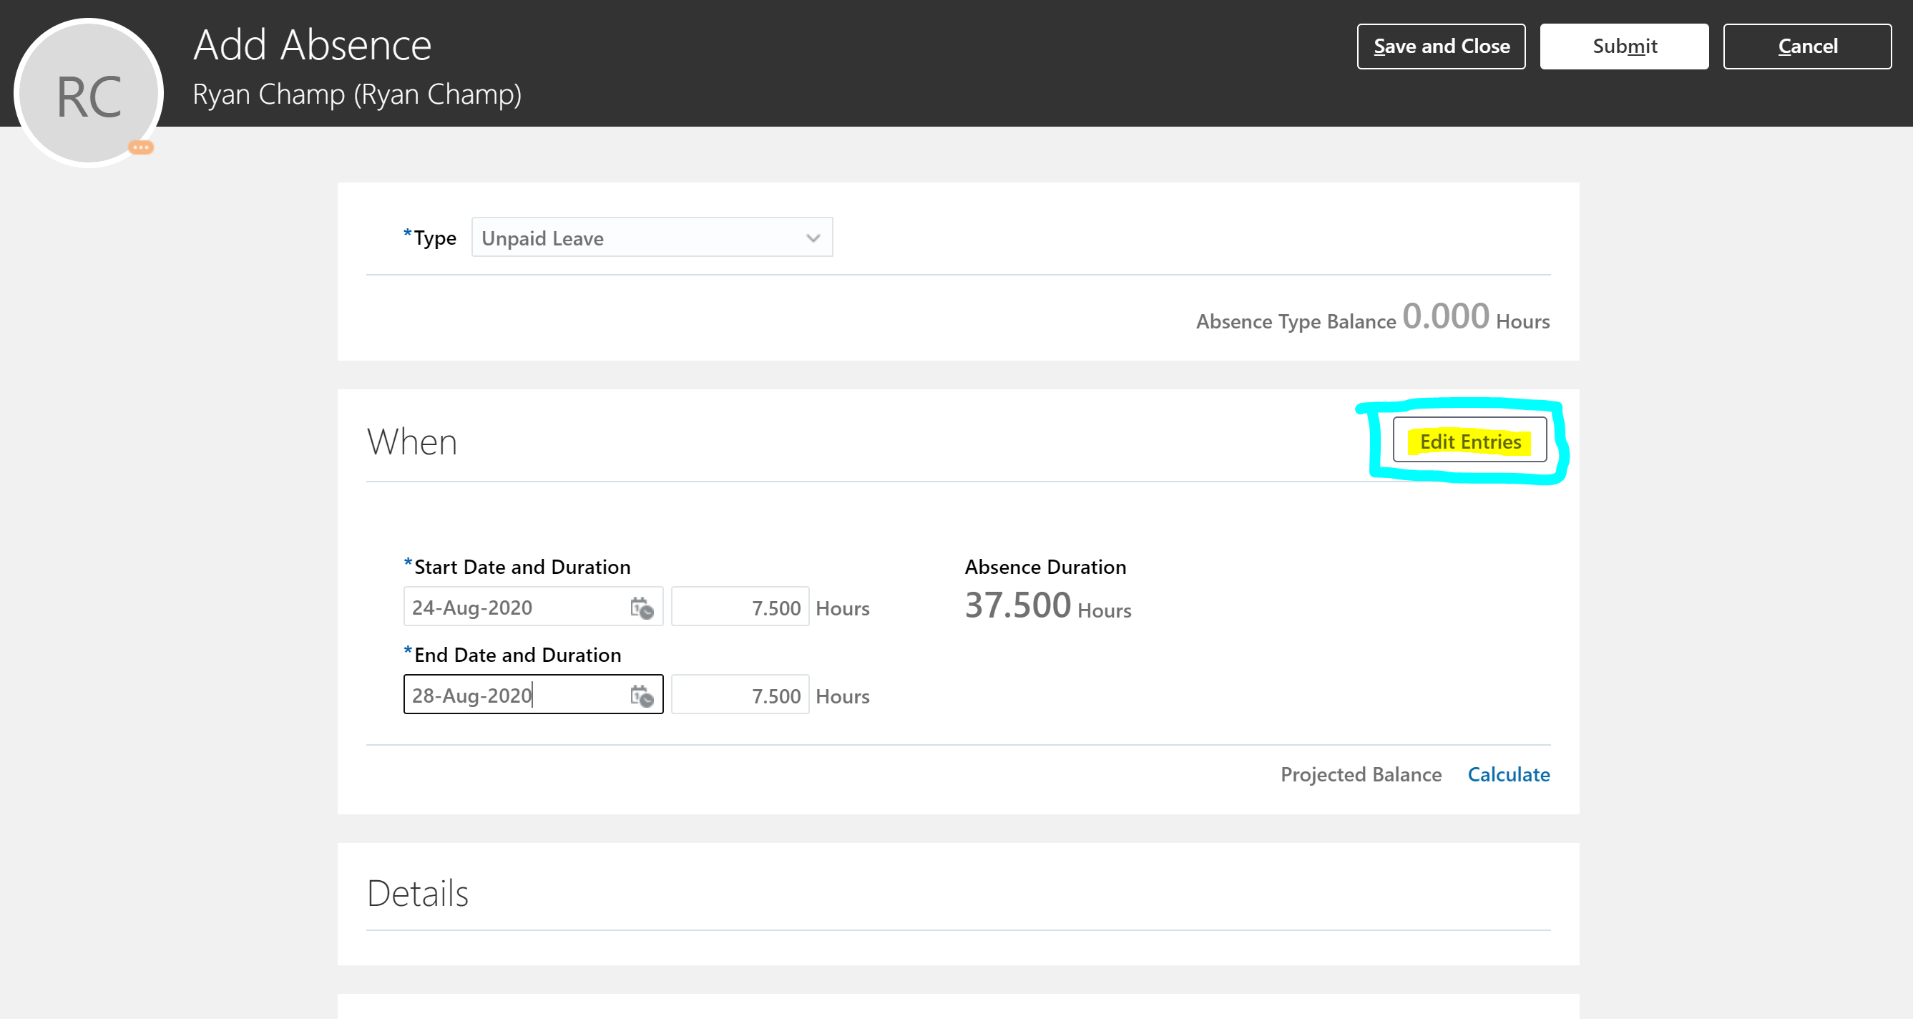
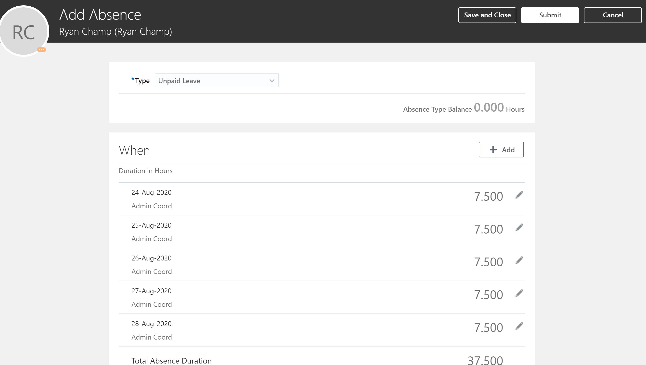

Click on the Pencil icon next to the hours to edit the details.
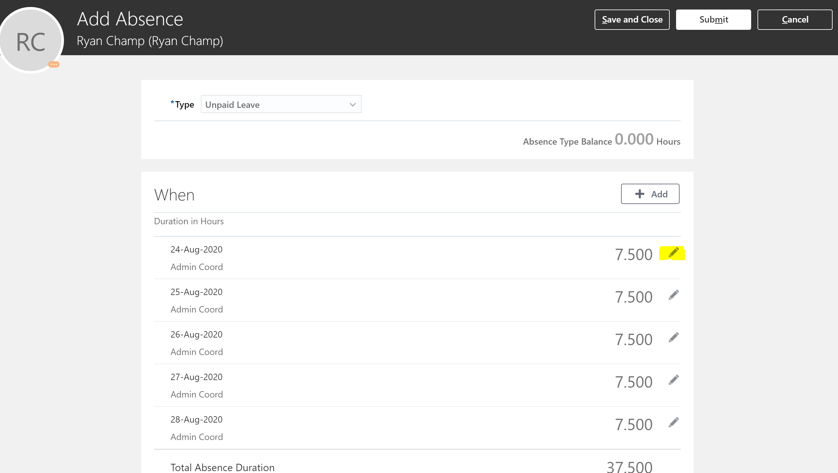

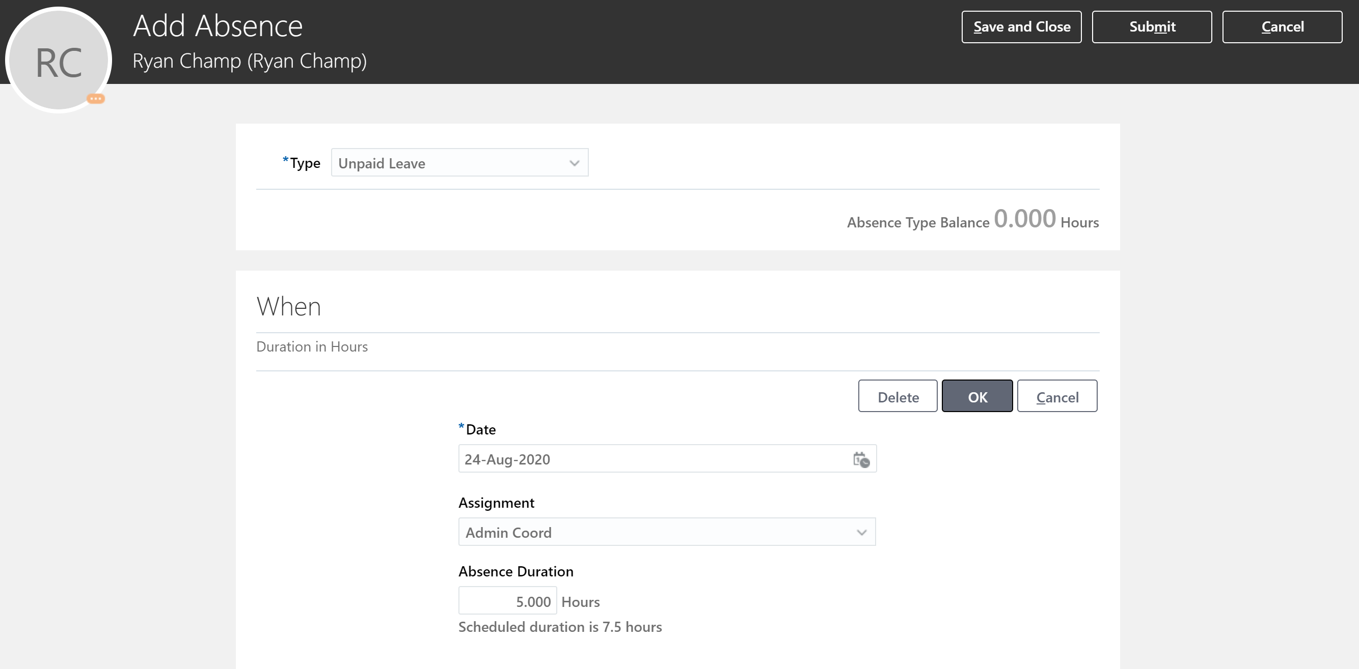
Click Ok after the changes have been made.
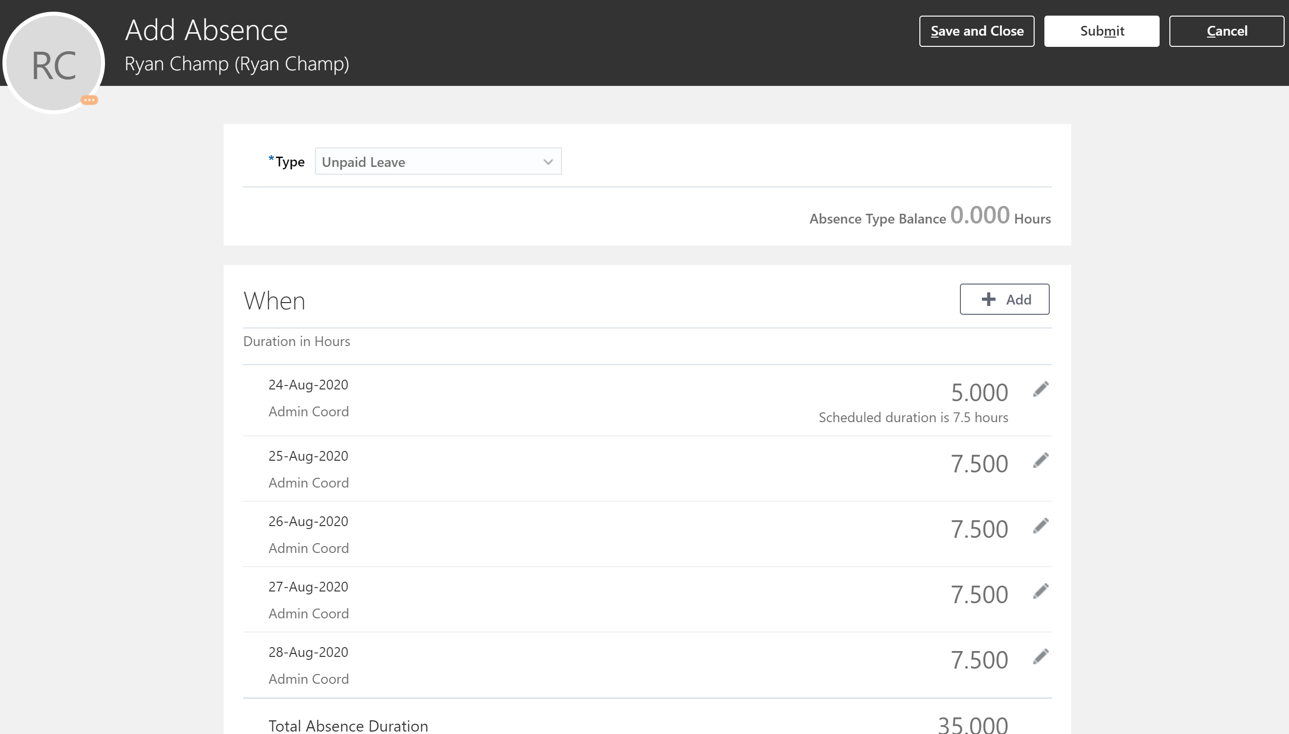
Click Submit button to submit the absence for Approval.

