New Absence Entry by Line Manager.
There are now three tasks “Add Absence, Absence Balance and Existing Absences” replaced the existing Task “Manage Absence Records”.
Before: “Manage Absence Records”
My Team:
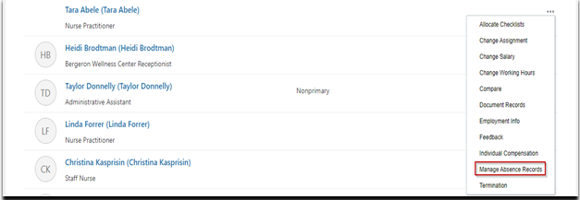
After: New Tasks: Add Balance, Absence Balance and Existing Absences replaced the Manage Absence records Task.
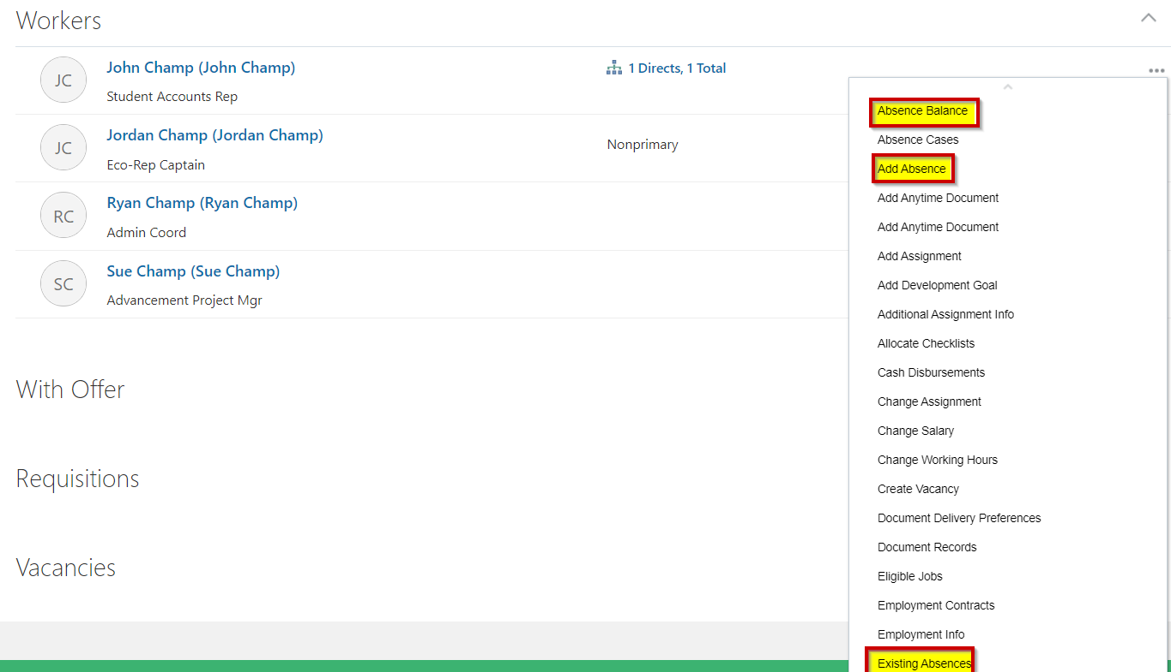
Is the Process changing?
Absence Balance: You can view the Accrual balances and enter an absence here.
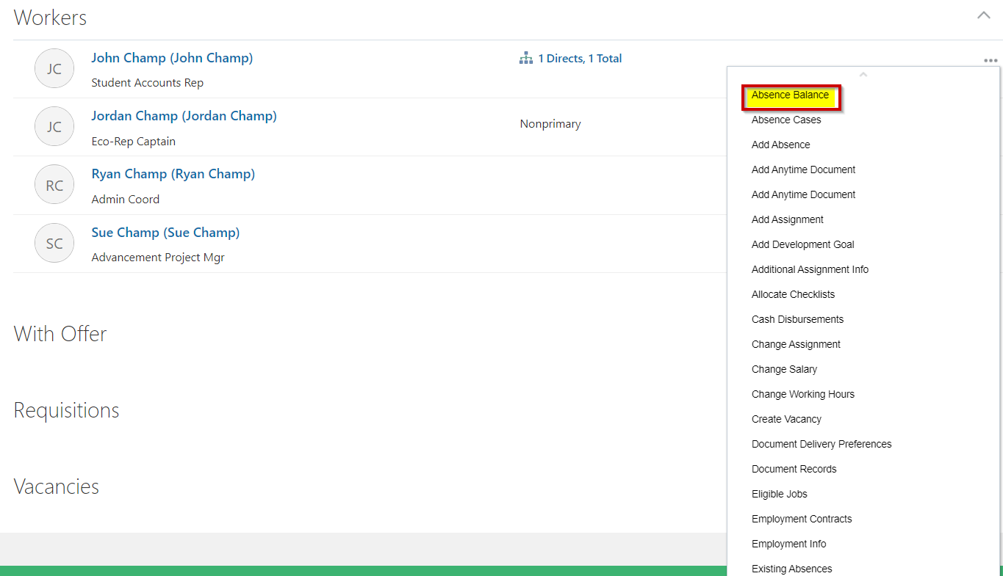
To enter an absence from this tile, click on the Actions Button on the top right corner as shown in the screen shot below:
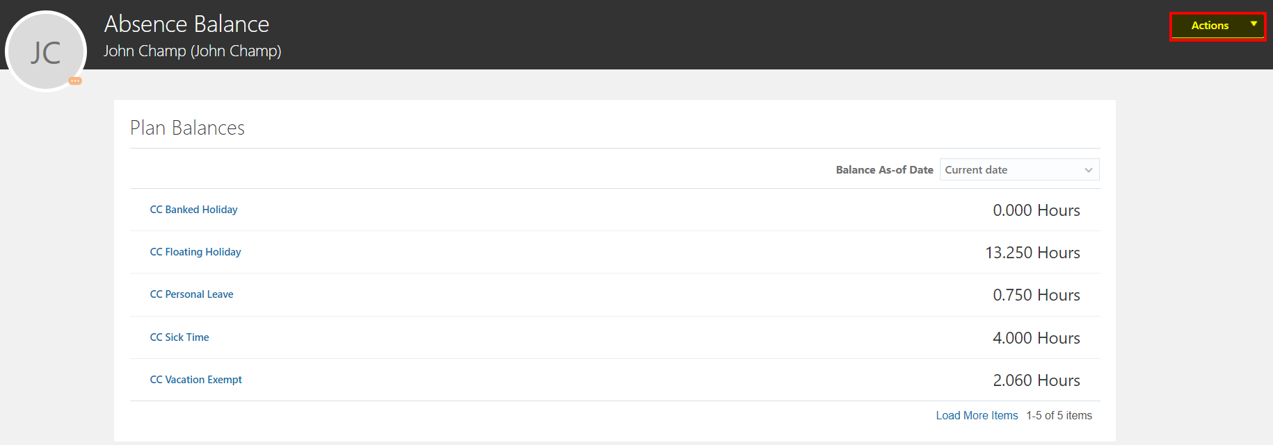
Click on Actions and Add Balance.
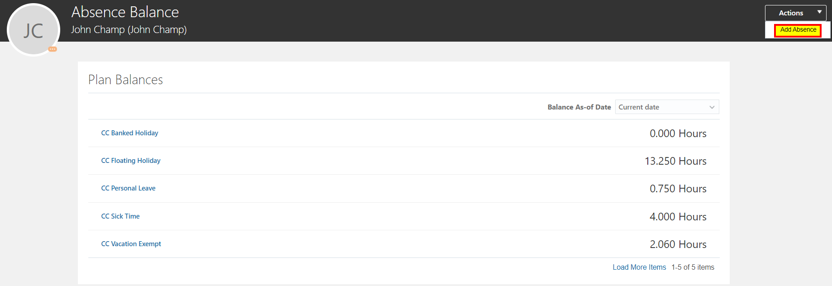
Select an Absence Type under the drop down
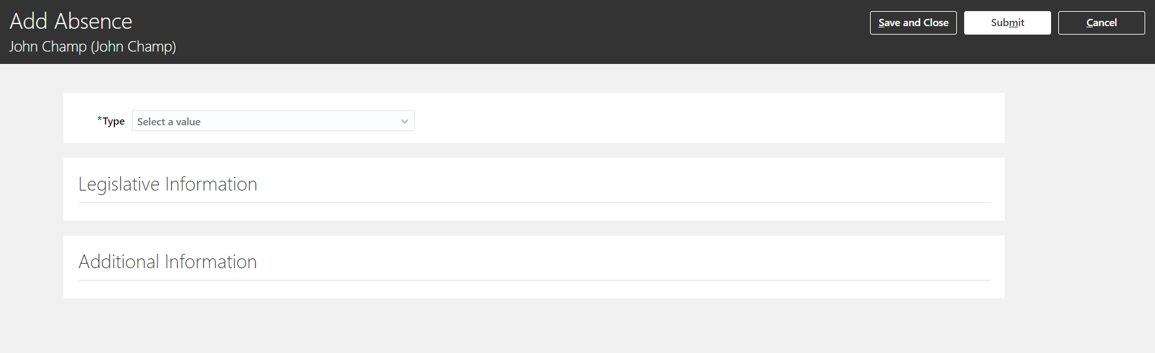
Enter your information
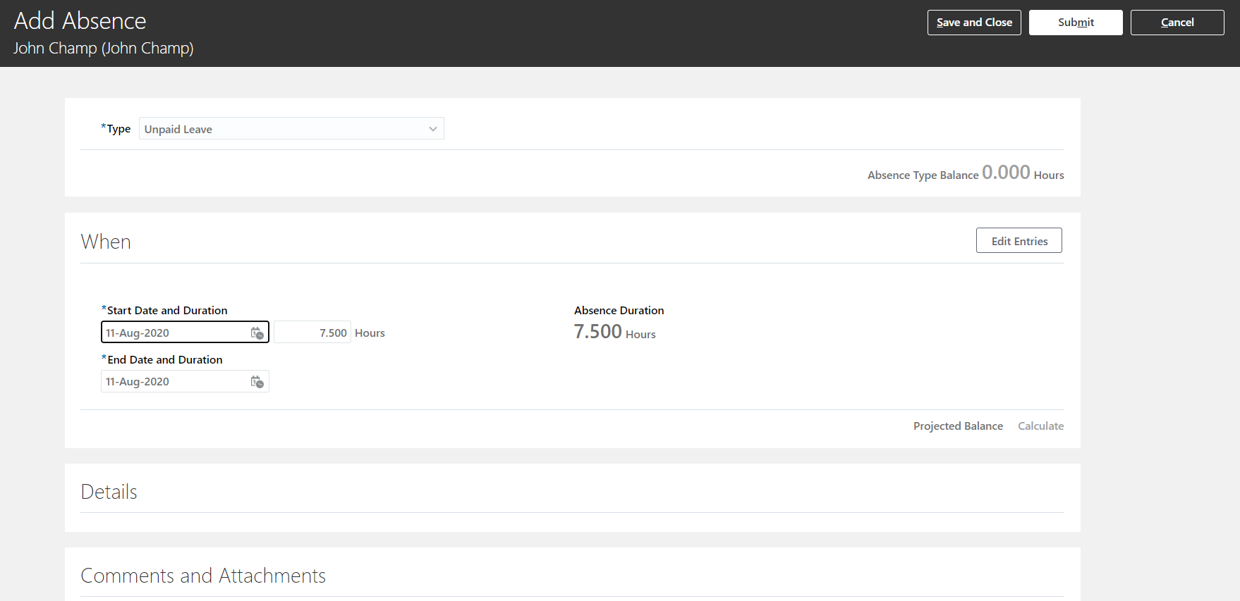
Click on Edit Entries to enter Absence for multiple Assignments.
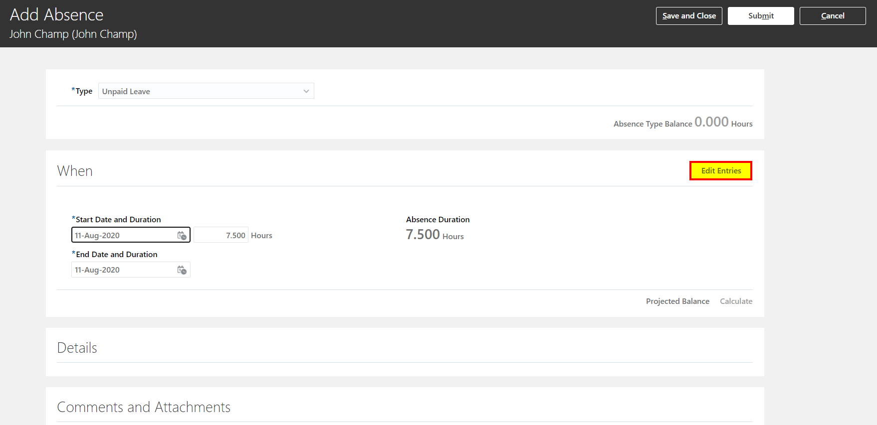
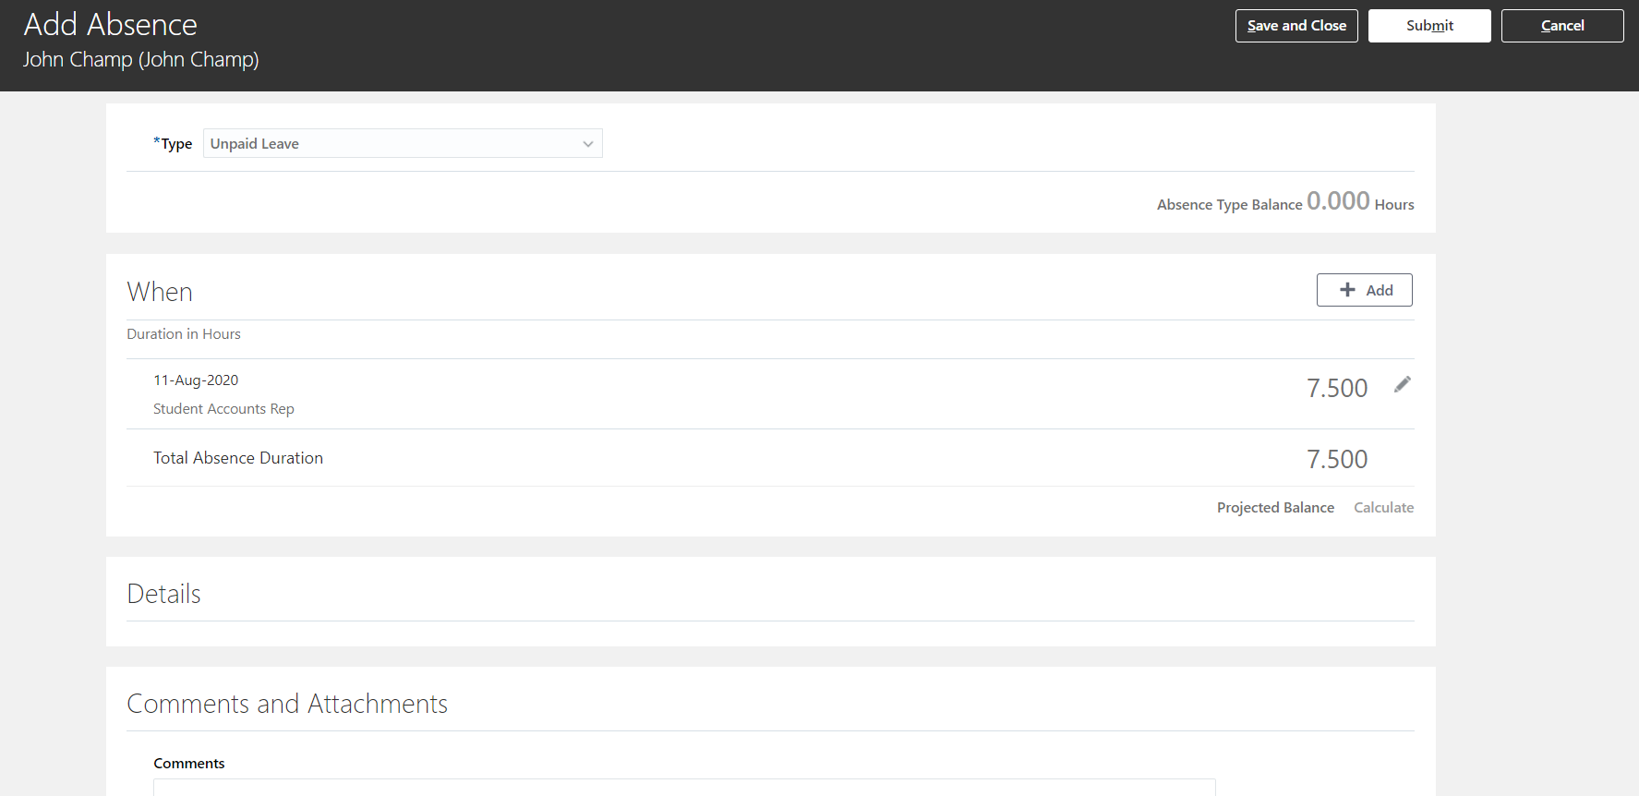
Click on the Pencil icon next to the hours to edit the details.
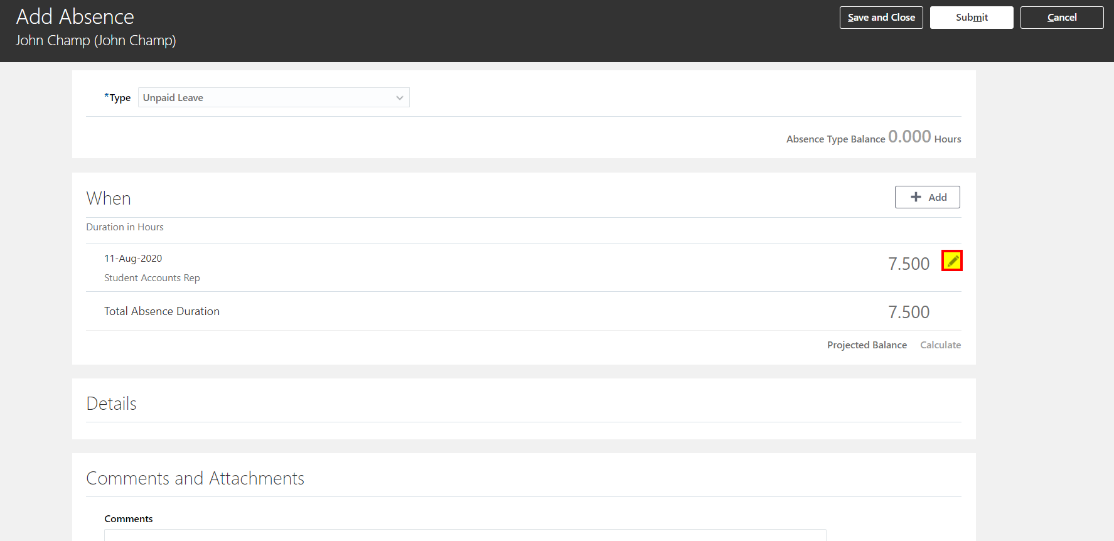
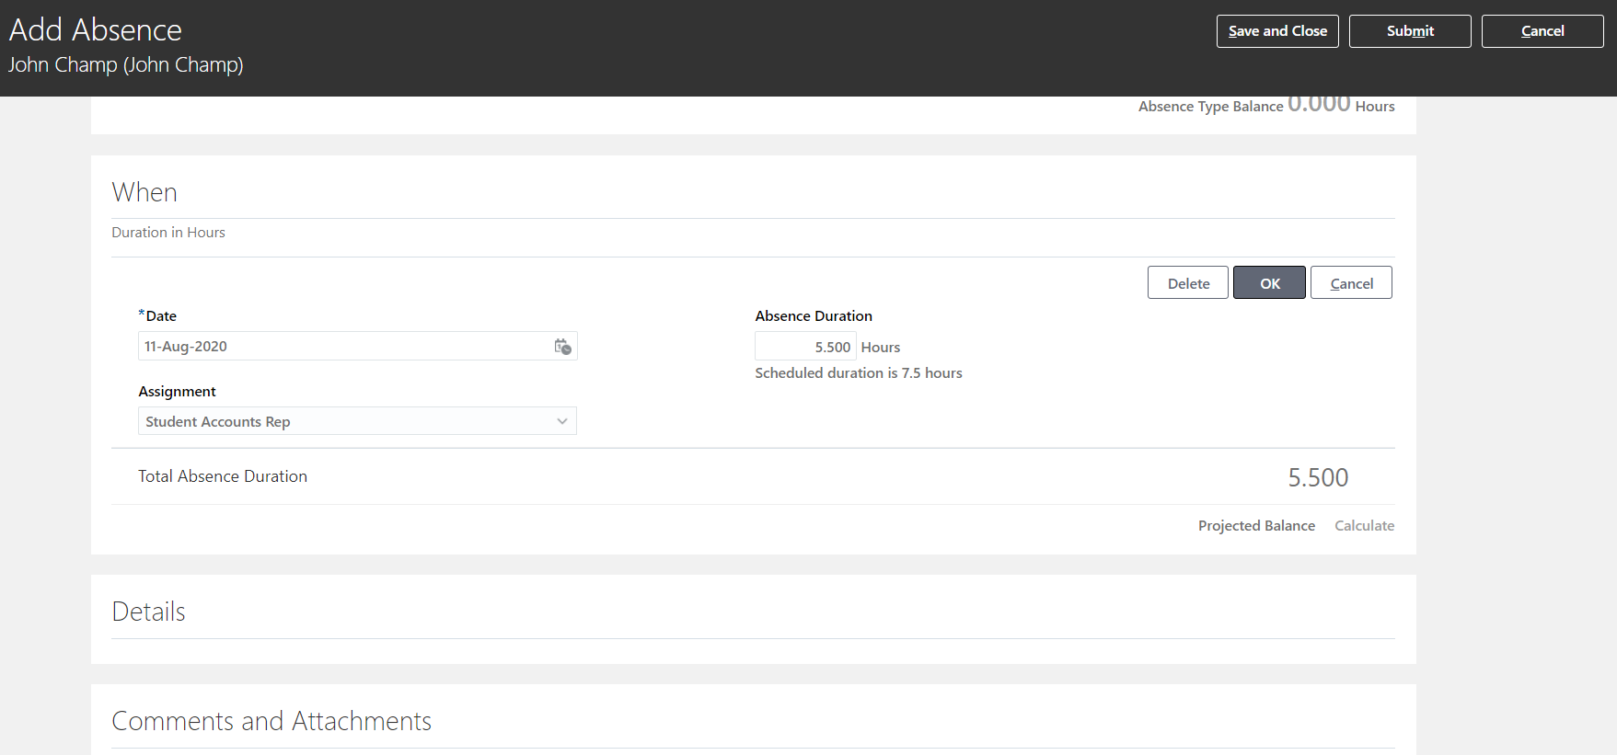
Click on OK after the changes have been made.
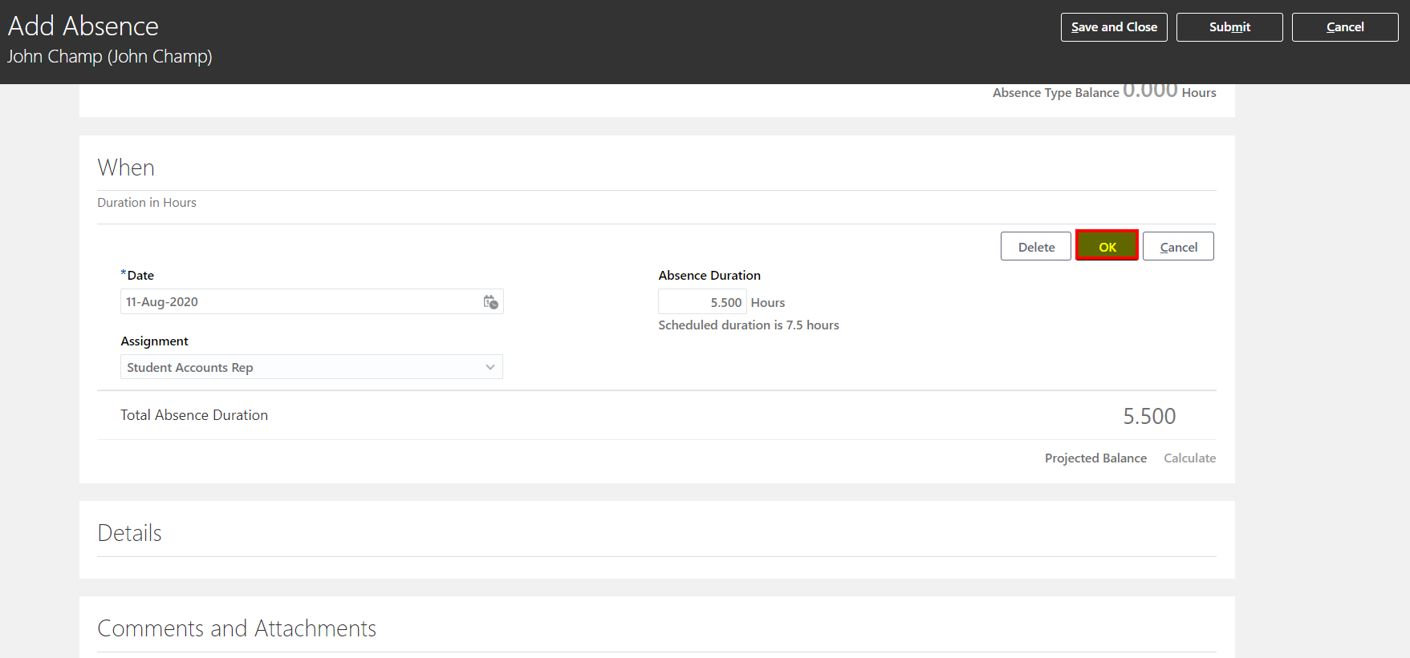
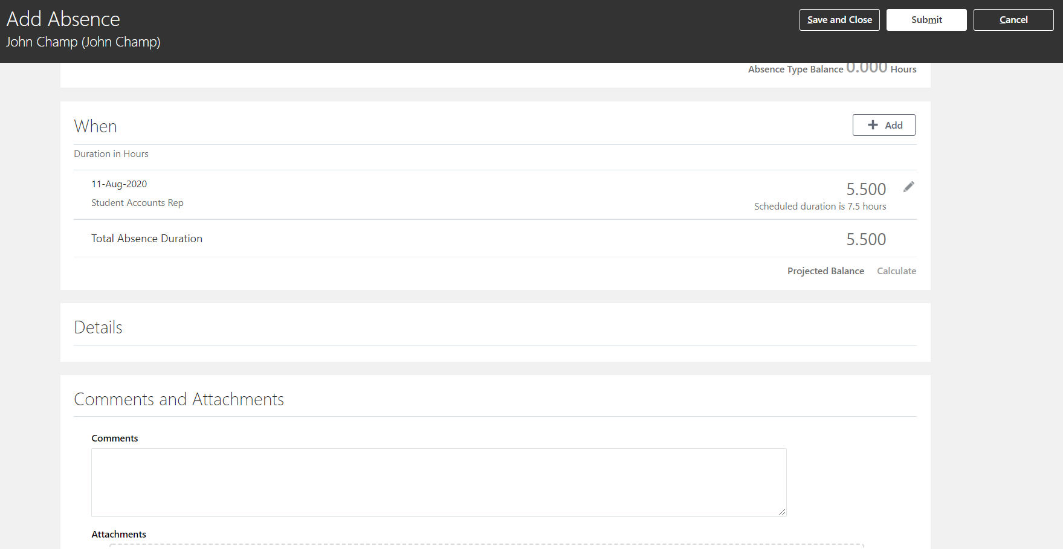
Click on Submit. The Absence Record is auto approved.
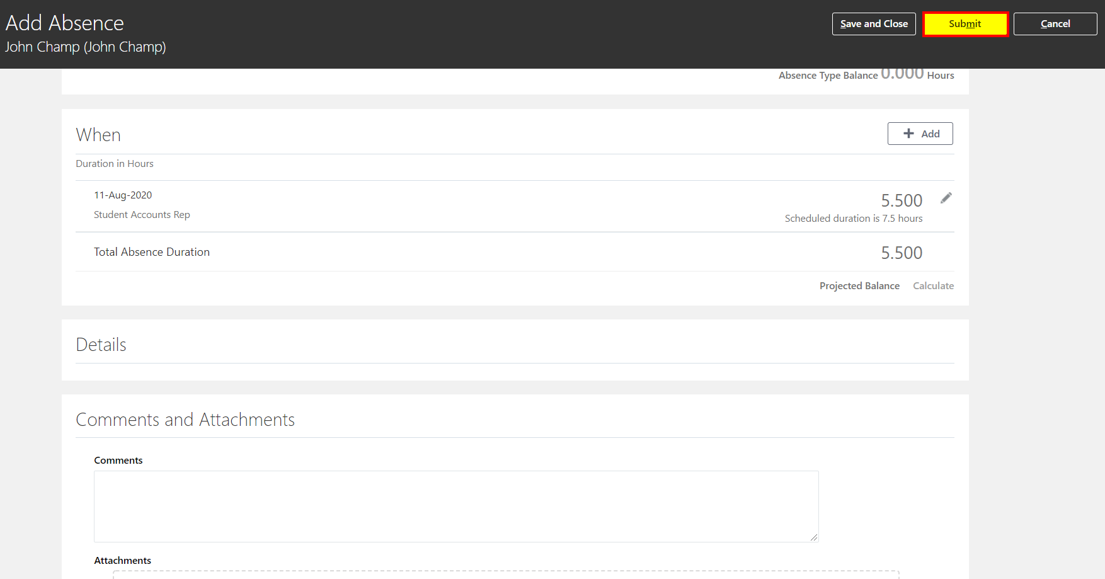
Task: Add Absence: Is used to Submit Absence Record on behalf of a Direct Report.
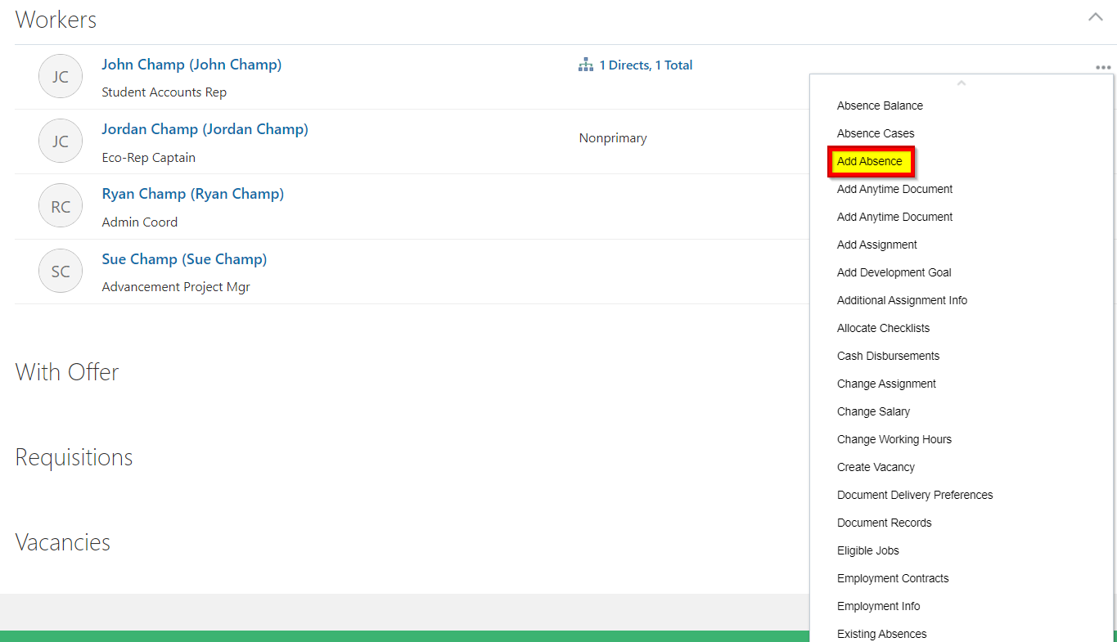
Select an Absence Type under the drop down
Enter your information
Click on Edit Entries to enter Absence for multiple Assignments.
Click on the Pencil icon next to the hours to edit the details.
Click on OK after the changes have been made.
Click on Submit. The Absence Record is auto approved.

Task: Existing Absences: View and Update Existing Absences and Submit New Absence Records.
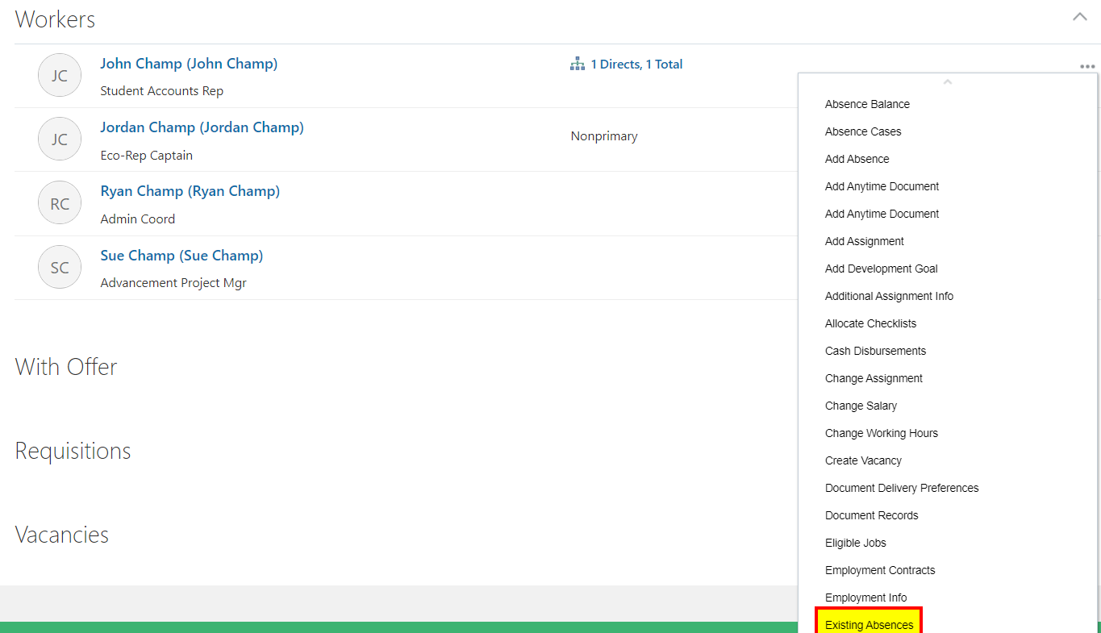
Add Absence: Click on Add. The screenshots are same as Add Absence Task.
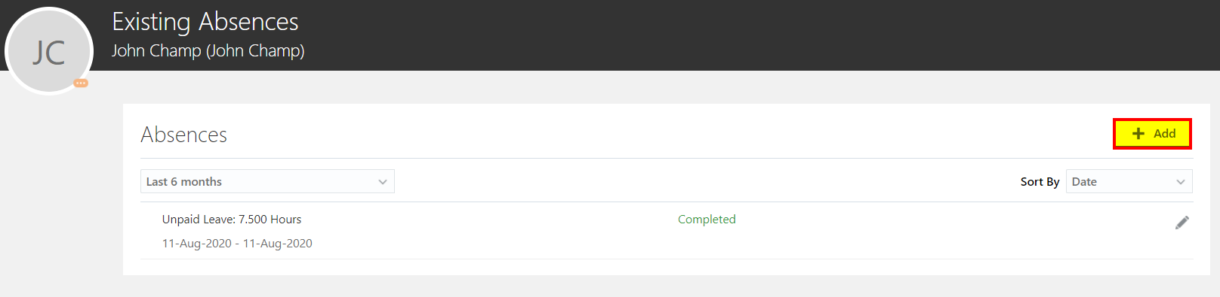
Select an Absence Type under the drop down
Enter your information
Click on Edit Entries to enter Absence for multiple Assignments.
Click on the Pencil icon next to the hours to edit the details.
Click on OK after the changes have been made.
Click on Submit. The Absence Record is auto approved.
Update Existing Absence Record: Click on the Pencil icon against the Absence Record.
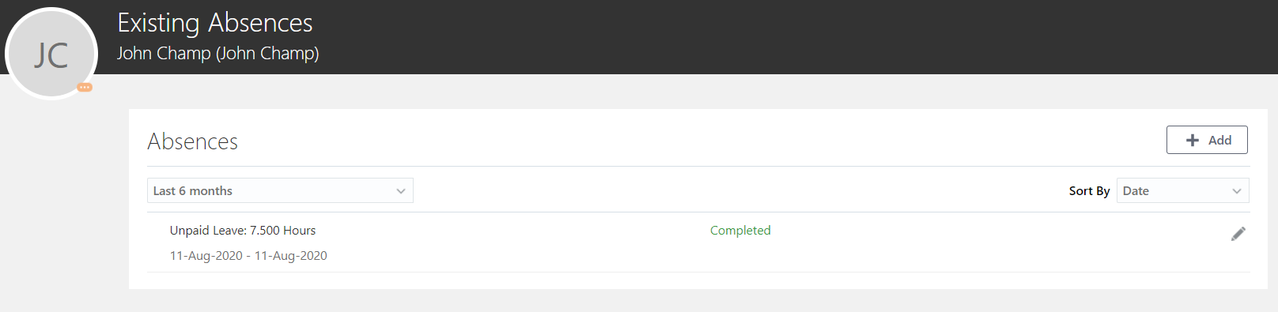
Click on the Pencil icon next to the hours to edit the details.
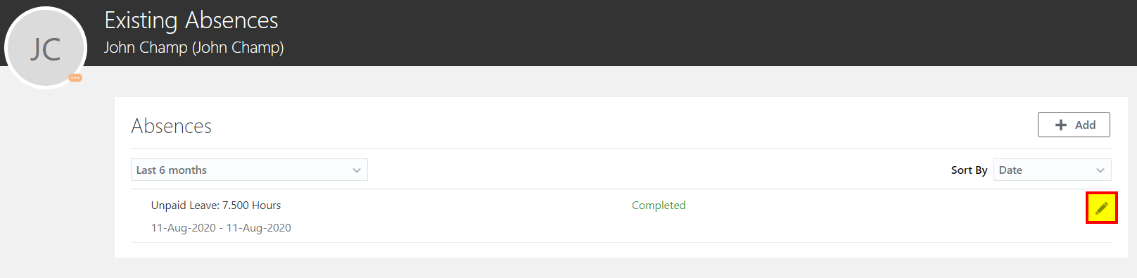
Click on OK after the changes have been made.
Click on Submit. The Absence Record is auto approved.

------------------------- END OF THE DOCUMENT ------------------------------

