Update Final COVID Vaccination Date
Purpose: The purpose of this document is to walk you through how to update the Final COVID Vaccination Date in Oracle.
Process Step & Description | Action
1.1 Navigation | Navigation:  Oracle Homepage → Me → Personal Information → Personal Details  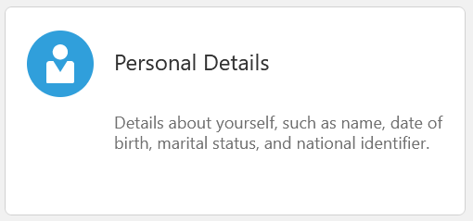
1.2 Update Final Vaccination Date | Under the Demographic Info section, select the Edit icon.  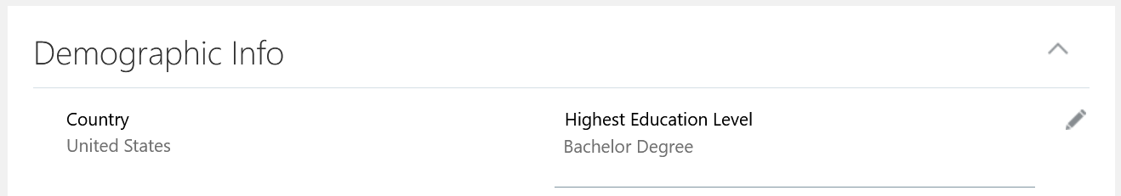  In the Final COVID Vaccination Date field, select the date of your final vaccination. For a two-dose vaccine (Moderna and Pfizer,) select the date of your second dose. For a single dose vaccine (Johnson & Johnson,) select the date of your one shot.  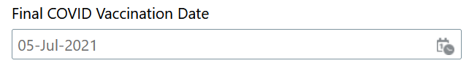  Once all updates have been made, select Submit.
1.3 Upload Vaccine Card to Documents | Navigation:  Oracle Homepage → Me → Personal Information → Document Records  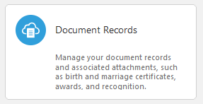  After registering your COVID vaccination date, you will want to upload your vaccine card to your document records.  To create a new document, click + Add.  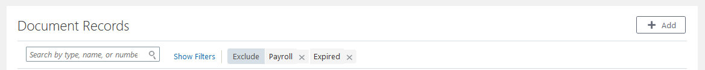  Select Other than Medical Reports as the document type.  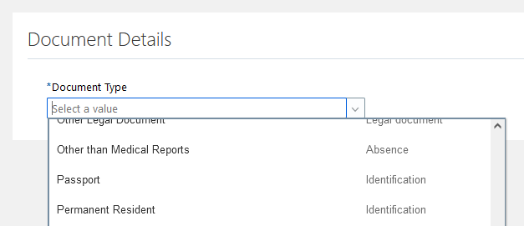  Complete the details and upload your scanned vaccine card.  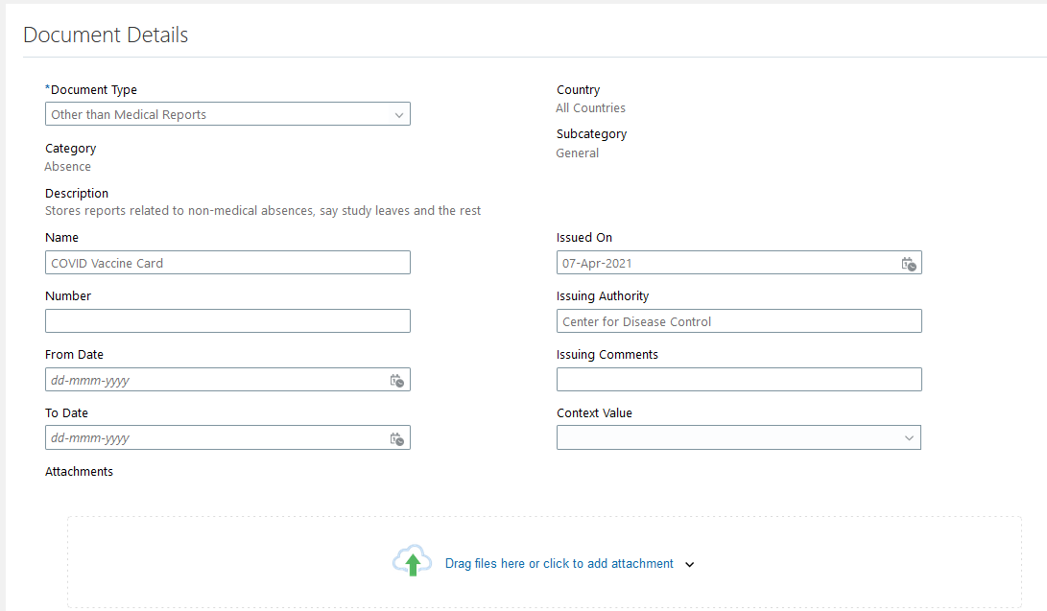  In the following fields:  - Name – COVID Vaccine Card  - Issue Date – Use date of your first vaccine shot  - Issuing Authority – Centers for Disease Control  - Issuing Comments – Name of vaccine (Pfizer, Moderna, Johnson & Johnson)  Note: Do not forget to scan and upload a copy of your vaccine card in the attachments section.  After completing the details and uploading a copy of your document, select Submit.

