How to Claim Host in Zoom

Note: All common GMHEC Zoom rooms have the same host key – 110022

- In a Zoom meeting, click on Participants

- A pop-up window should appear listing all of the participants that are in the meeting. If no one has been assigned the host, you will have the ability to claim that role. Click Claim Host at the bottom of the participants list
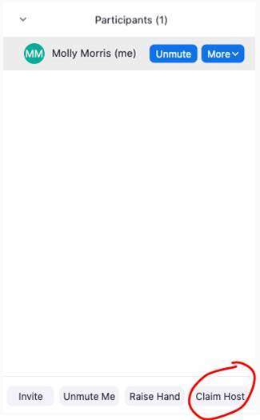
- You will then be prompted to enter a host key. The host key for all GMHEC common meeting rooms is 110022

How to Locate Host Key for Personal Zoom Room
These steps will outline how to locate the host key for your own personal Zoom room.
- Open a new web browser and navigate to https://zoom.us
- Sign in to Zoom using your GMHEC credentials
- Navigate to the Profile tab
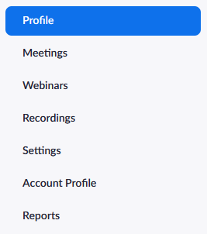
- Scroll down to the Meeting section – this will list information like your Personal Meeting ID, Personal Link, and your Host Key
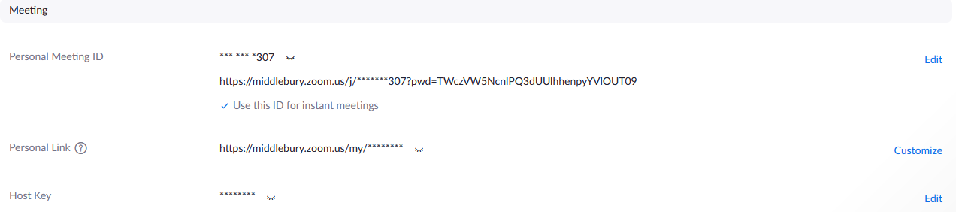
- To view your host key, click on the small eyelashes icon
- To change your host key, click on the Edit button

